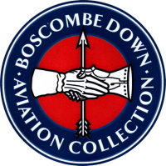

THE BOSCOMBE DOWN AVIATION COLLECTION

PRESENTATIONS 2024
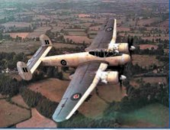

Our next presentation of the season is LIVE at BDAC

Tuesday 9th July 2024
1900hrs

Flying the Bristol Brigand and More

Vic Campden MBE

Our 98 year old speaker wanting to play his part in WW2 in the RAF passed aircrew selection in 1943 but because of system delays he was not finally selected until 1946 and then as a National Serviceman. He was awarded his wings in 1948 after basic training on Tiger Moths and Harvards, he completed his advanced training on Mosquitos. Vic went on to fly Brigands in Iraq and Aden. His final tour was flying Ansons and Proctors at RAF Swanton Morley being demobbed in 1952. In the 60’s he was heavily involved in the ROC and rose to become Group Commandant 24 Gp ROC.

